Yes, so this chapter is next Capacitors with Grandpa, ends with the button Capacitors and button lesson. What’s the intro? Feeling lost in the moment, lost track of Marvin Marindale and aliens and robots
Felt antsy, went to work with Grandpa, he forces the issue, makes Gavin send a text.
Then they do the capacitors lesson.
Explain how capacitors work.
The lesson is done. Gavin gets a new text from Aanya right as he’s finishing up

Capacitors lesson is your lesson from robotics

a capacitor is a component that can store and release electric charge. “It’s like a reservoir that you fill up and release as needed,” Grandpa said.
It looks like this:
(sketch)

“I’ve got a really old one here that I’ve unrolled,” said Grandpa

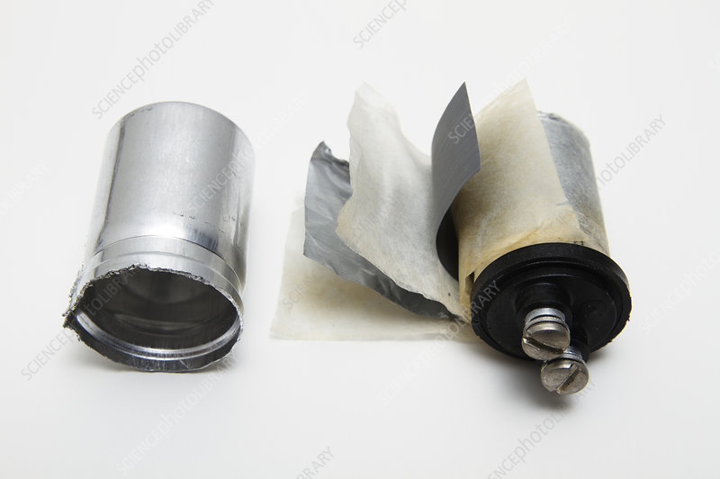

Here’s how Grandpa explained it to me:
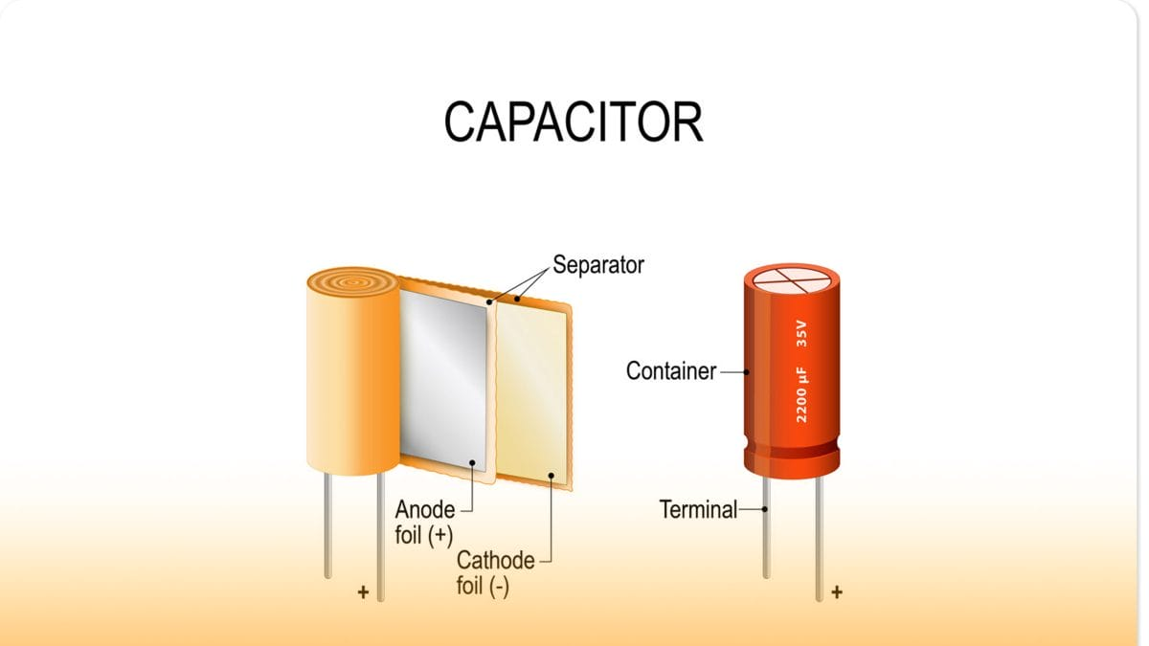

(explain capacitors)

Capacitors store electrical energy in an electric field between the two conductive plates inside. Understanding the exact mechanics of how that all works is college-level stuff that we won’t get into, but you should read the four bullet points below:

- When you first connect a capacitor to a power source, it is empty and has no voltage across it, so a large initial current flows.
- As the capacitor charges, the voltage across its plates increases. This stored voltage creates a reverse electric field that pushes back against the incoming current from the power supply.
- The difference between the power supply voltage and the capacitor's stored voltage decreases, causing the charging current to drop exponentially.
- When the capacitor is fully charged and its voltage equals the power supply's voltage, the current stops flowing completely. This eliminates any further heating from electrical resistance.

Today we’re going to use a 1000uF capacitor rated for 35V (I just bought them! I’m so excited!)
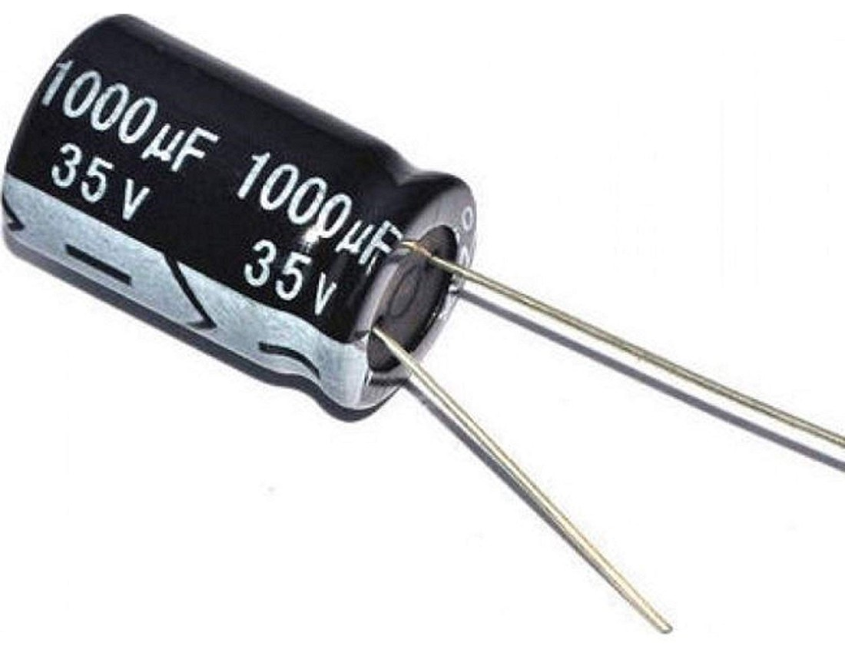

Build this circuit in steps
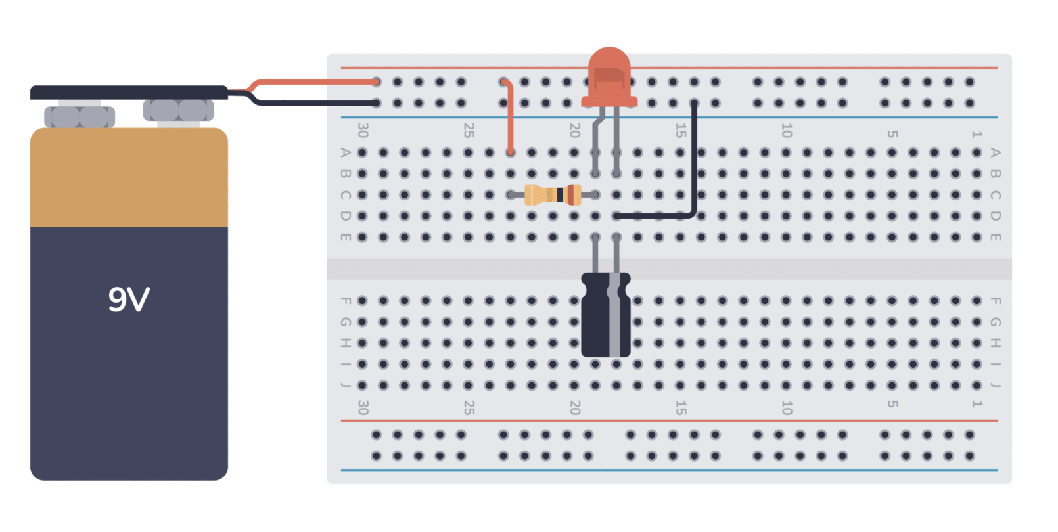
Have Grandpa show him how to discharge a capacitor too.
“Hang on, Grandpa,” I said. “Emergency.”
“Emergency?”
“Look at this text I just got.” I handed him the phone.
Aanya: You want to come over now?
Grandpa read the text, set down the phone, and gently closed the book. “Well clearly capacitance can wait,” he said.
He slid the phone across the workbench. I grabbed it and typed, Be there soon.

